classroom attendance recorder

This software created in 2021.

# Index

|  |  |  |
| --- | --- | --- |
| Sr.no |  |  |
| 1 | Introduction | 1. Introduction of “Classroom-Attendance-Recorder” software. |
| 2 | Essential primary things to work the software correctly! | 1. Where to install the software. 2. Adding student’s names to “Google_Attendance” excel sheet. 3. Creating google meet link and fixing it to google calendar. 4. Adding email, password and google meet link to “Login and meet link.xlsx” excel sheet. |
| 3 | How the code is working and what packages are used? | 1. Packages installed. 2. Code explanation |
| 4 | Error you may face while using this software. | 1. Stuck to “Ask to join” page in google meet. 2. Sign in problem in google meet. (This browser or app may not be secure) 3. Cannot use “Restore” button to restore the email, password and google meet link. 4. Unhandled exception in script. Failed to execute script ‘Classroom-Attendance-Recorder’ due to unhandled exception: bitmap. 5. Stuck at “Getting ready” page in google meet. 6. Automated software didn’t get out of google meet. i.e. software stuck in joined google meet. |

# Introduction

1. Introduction of “Classroom-Attendance-Recorder” software –

This software is created by B.Tech student . Because we wanted to learn the selenium and automation in python. Thus this software is created with help of python programming language and with help of selenium and openpyxl library. It is actually used for taking attendance of student present in “Google meet”.

Due to covid situation colleges are taking their class online with help of google meet and zoom meet software. But, after the lecture teacher takes attendance by calling name of each and every student from their attendance list. This more time taking and also energy wasting process.

So to solve that problem, we engineering student came with idea to take attendance by using automation in python. Automation means automatically doing a task with help of computer. In this software, chrome driver is used to sign in with the users email and password and then join to google meet and record the student attendance in excel sheet and it automatically left the meeting and close the browser.

# Essential primary things to work the software correctly!

## Where to install this software –

1. If you already download the “Classroom-Attendance-Recorder-Setup” file then just double click on that setup to install.
2. After install you will find out that software is already installed specific location i.e. C:\Classroom-Attendance-Recorder.
3. The path of installation is already fixed you cannot change it because the python code is based on that C driver.
4. The paths of chrome driver and the icon of the software is present inside that folder and similar paths are written in python code.
5. **IMP- if you change the location of folder then some error may get produced which are discussed next pages.**
6. Adding student’s names to “Google_Attendance.xlsx” excel sheet
7. After the installation the “Google_Attendance.xlsx” a excel sheet will be there.

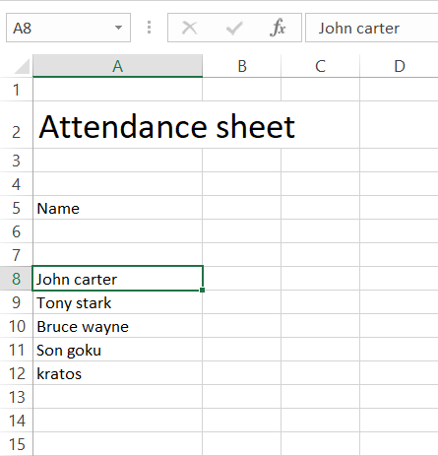

1. In this excel sheet, as you can see “John carter” names start from row = 8 and column = A. Similarly start adding the name of student from the cell number A8 i.e. row = 8 and column = A and go downward to add more names. If write names of student correctly then student attendance will be taken without any errors.

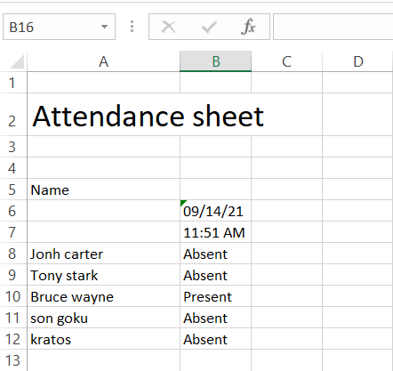

1. Creating google meet link and fixing it to google calendar.
2. For creating the google meet go to “ <https://meet.google.com>”.
3. 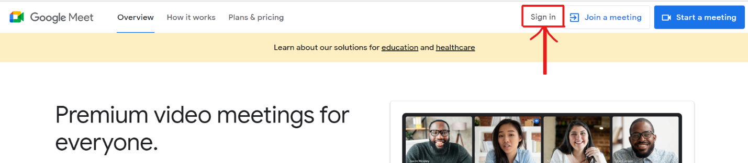Click on the “Sign in” button on top right corner.
4. Sign in with email id and password.
5. After that click on New meeting button.

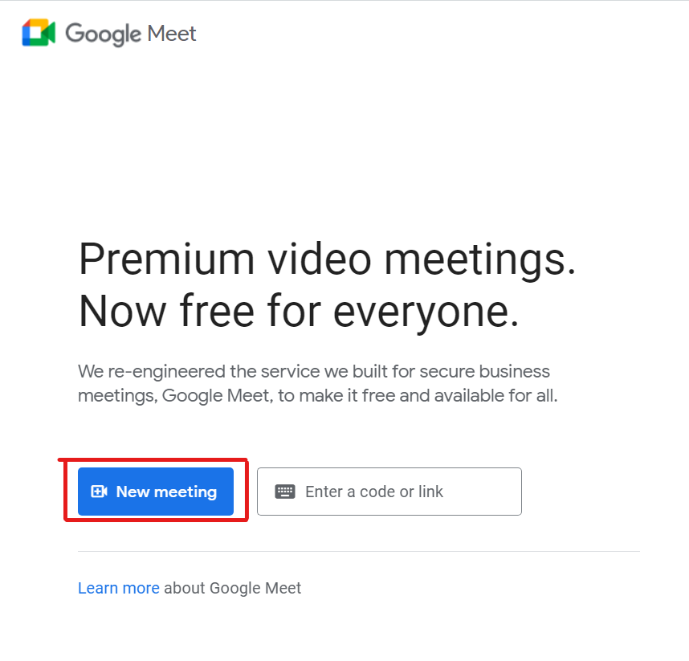

1. Click on “Schedule in Google Calendar”

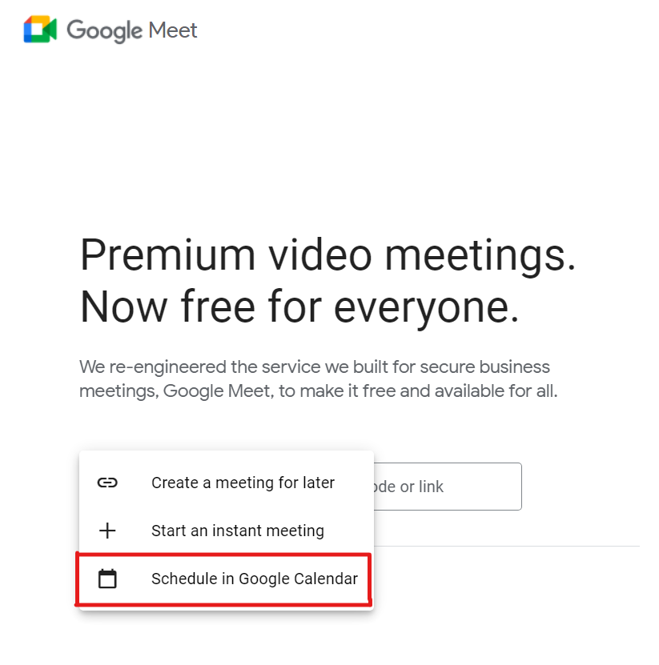

1. Next the below window will appear. Create the meeting by entering all details mentioned below. First click on “All day” checkbox. Then enter the title, date upto which lectures going to happen and finally enter the email address in “Add guest” box. This email address will be used for entering into google meet and taking the attendance of student. The problem with email address is that google don’t allow automation with “gmail.com” email id. **So, when you upload the email id it must have other domain name except “gmail.com”.**

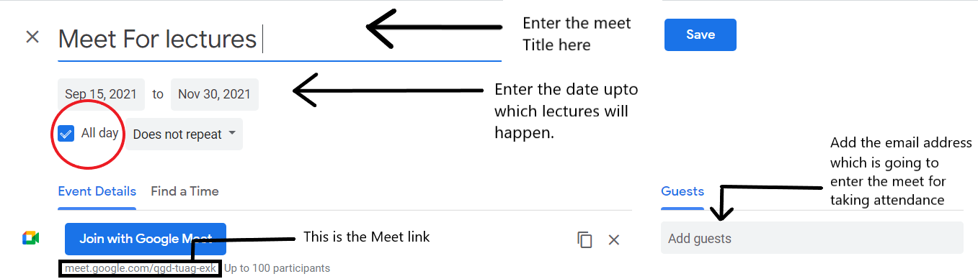

1. Adding email, password and google meet link to “Login and meet link.xlsx” excel sheet.
2. After installation the “Login and meet link.xlsx” excel sheet will be there. After opening you will get the content like this.

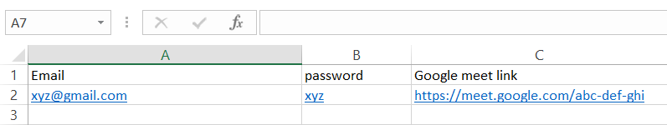

1. Replace the email address i.e. “[xyz@gmail.com](mailto:xyz@gmail.com)” with your Email id. The problem with email address is that google don’t allow automation with “gmail.com” email id’s. **So when you upload the email id it must have other domain name except “gmail.com”.** ( write in row=2 and column=A )
2. Replace the password i.e. “xyz” with your Email id password. ( write in row=2 and column=B )
3. Replace the Google meet link i.e. “<https://meet.google.com/abc-def-ghi>” with the google meet link you created already. It also found in google calendar. ( write in row=2 and column=C )